Static Timing Analysis

Lab3: Case Analysys

Objective
To study:
- Generating Endpoint slack diagram
- Generating delay calculation reports
- Understand delay calculation principle.

Laboratory task
- Load Gate Level design into PrimeTime
- Do case analysis.

Supporting information for doing laboratory work
Laboratory work is performed on a gate level design generated by compiling given RTL code (Listing 3.1) using Design Compiler (Fig 3.1). Sample SDC file is also provided as reference (Listing 3.2).
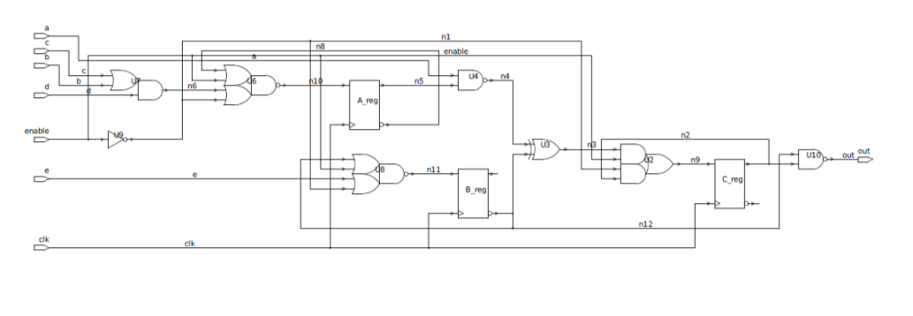
Fig. 3.1. A Sample Circuit

Listing 3.1 Example Circuit RTL (circuit.v)
module circuit (enable, a,b,c,d,e,clk,out);
input a;
input b;
input c;
input d;
input e;

input clk;
output out;
reg A;
reg B;
reg C;

wire Bq_or_a_nand_Aq;
wire d_nand_c_or_b;
wire a_nand_Aq;
wire not_e;
wire out;

assign d_nand_c_or_b= ~(d * (c | b));
assign not_e=~(e);
assign a_nand_Aq= ~(a * A);
assign Bq_or_a_nand_Aq= (~(B)) + (a_nand_Aq);

assign out= ~( ~(B) * C);

always @ (posedge clk)
begin
if (enable)
begin
A= d_nand_c_or_b;
B= not_e;
C= Bq_or_a_nand_Aq;
end
end

endmodule
Listing 3.2 Example Circuit Constraints (circuit.sdc)
set PERIOD 10

set_load -pin_load 0.04 [get_ports {out}]

create_clock [get_ports clk] -period $PERIOD -waveform {0 5}
set_clock_uncertainty [expr 0.1*$PERIOD] [get_clocks clk]

set_input_delay -clock clk [expr 0.6*$PERIOD] [get_ports a]
set_input_delay -clock clk [expr 0.6*$PERIOD] [get_ports b]
set_input_delay -clock clk [expr 0.6*$PERIOD] [get_ports c]
set_input_delay -clock clk [expr 0.6*$PERIOD] [get_ports d]
set_input_delay -clock clk [expr 0.6*$PERIOD] [get_ports e]
set_output_delay -clock clk [expr 0.6*$PERIOD] [get_ports {out}]

1. Loading Gate Level design into PrimeTime
First load design along with constraints into PrimeTime. Below is a sample script to it.

set link_library ../liberty/saed05nlplogl06hdl060f_tt0p75v25c.db
read_verilog ./enable_circuit_gate.v
read_sdc ./enable_circuit.sdc

2. Generating Timing report for different cases
This circuit is built in a way that “enable” bin turns part of a circuit on or off. Thus, setting enable to “0” or “1” changes the worst path in the circuit. To find timing problems for different cases, case analysis is used.

Use the following commands:
set_case_analysis 1 enable
report_timing

Resulting report
****************************************
Report : timing
-path_type full
-delay_type max
-max_paths 1
-sort_by slack
Design : circuit
Version: S-2021.06-SP4
Date : Tue Dec 13 10:29:57 2022
****************************************

Startpoint: a (input port clocked by clk)
Endpoint: C_reg (rising edge-triggered flip-flop clocked by clk)
Path Group: clk
Path Type: max

Point Incr Path
---------------------------------------------------------------
clock clk (rise edge) 0.00 0.00
clock network delay (ideal) 0.00 0.00
input external delay 6.00 6.00 r
a (in) 0.00 6.00 r
U12/X (SAEDSVT05_AN2_1) 0.00 6.00 r
U5/S (SAEDSVT05_ADDH_1) 0.00 6.00 f
U4/X (SAEDSVT05_AO22_1) 0.00 6.01 f
C_reg/D (SAEDSVT05_FDPQ_2) 0.00 6.01 f
data arrival time 6.01

clock clk (rise edge) 10.00 10.00
clock network delay (ideal) 0.00 10.00
clock reconvergence pessimism 0.00 10.00
clock uncertainty -1.00 9.00
C_reg/CK (SAEDSVT05_FDPQ_2) 9.00 r
library setup time -0.01 8.99
data required time 8.99
---------------------------------------------------------------
data required time 8.99
data arrival time -6.01
---------------------------------------------------------------
slack (MET) 2.98

Changing enable signal to “1” changes worst path:

set_case_analysis 0 enable
report_timing

Report:
****************************************
Report : timing
-path_type full
-delay_type max
-max_paths 1
-sort_by slack
Design : circuit
Version: S-2021.06-SP4
Date : Tue Dec 13 10:30:11 2022
****************************************

Startpoint: B_reg (rising edge-triggered flip-flop clocked by clk)
Endpoint: out (output port clocked by clk)
Path Group: clk
Path Type: max

Point Incr Path
---------------------------------------------------------------
clock clk (rise edge) 0.00 0.00
clock network delay (ideal) 0.00 0.00
B_reg/CK (SAEDSVT05_FDPQ_2) 0.00 0.00 r
B_reg/X (SAEDSVT05_FDPQ_2) 0.00 0.00 f
U11/X (SAEDSVT05_INV_1) 0.00 0.01 r
U16/X (SAEDSVT05_ND2_1) 0.00 0.01 f
out (out) 0.00 0.01 f
data arrival time 0.01

clock clk (rise edge) 10.00 10.00
clock network delay (ideal) 0.00 10.00
clock reconvergence pessimism 0.00 10.00
clock uncertainty -1.00 9.00
output external delay -6.00 3.00
data required time 3.00
---------------------------------------------------------------
data required time 3.00
data arrival time -0.01
---------------------------------------------------------------
slack (MET) 2.99

Report
The report should have:
- Design Compiler and PrimeTime scripts
- The gate level circuit
- Case analysis setup
- Timing reports for all cases
- Brief summary.

